**Phase 3:-** **SQL Operations**

Question :- 3.1 Insert records from 42_District_wise_crimes_committed_against_women_2001_2012.csv into a table.

Answer :- To solve this question, I created a database named ‘phase3.’ After that, I created a table and inserted only 3 records into that table. The remaining records were imported by selecting the table and following the path ‘Table Data Import Wizard.’

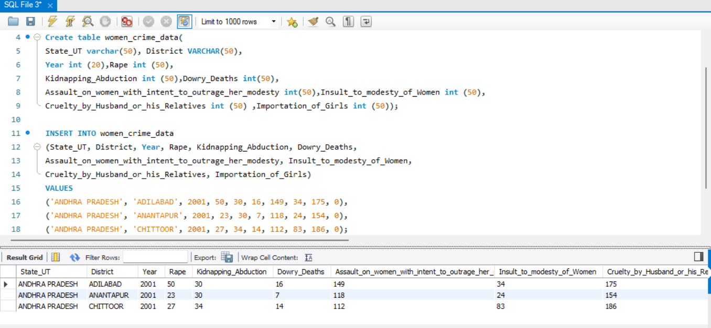

----------------------------------------------------------------------------------------------------------------------------------------------------

Question :- 3.2 Write SQL query to find the highest number of rapes & Kidnappings that happened in which state, District, and year.

Answer:-For Highest Rape and Kidnapping

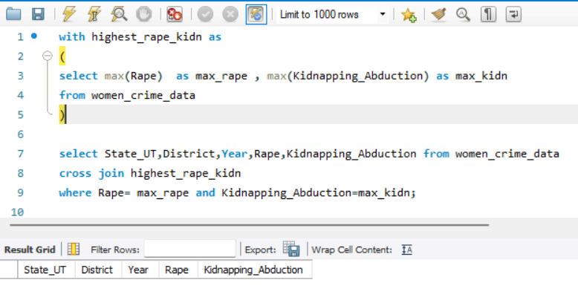

Question :- 3.3 Write SQL query to find All the lowest number of rapes & Kidnappings that happened in which state, District, and year

Answer:- For Lowest Rape and Kidnapping

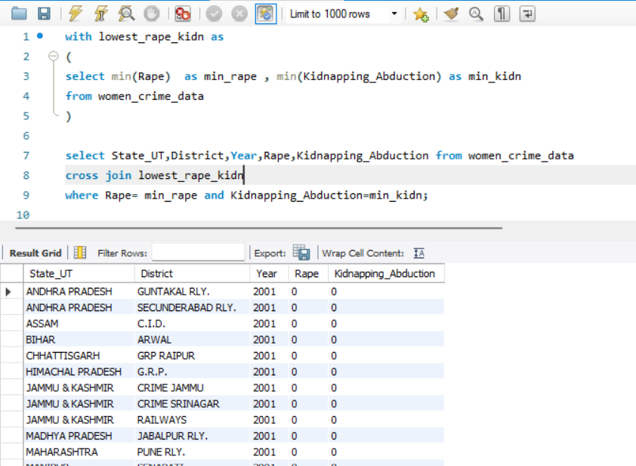

---------------------------------------------------------------------------------Question: - 3.4 Insert records from 02_District_wise_crimes_committed_against_ST_2001_2012.csv into a new table

Answer:- I created a table and inserted only 3 records into that table. The remaining records were imported by selecting the table and following the path ‘Table Data Import Wizard.’

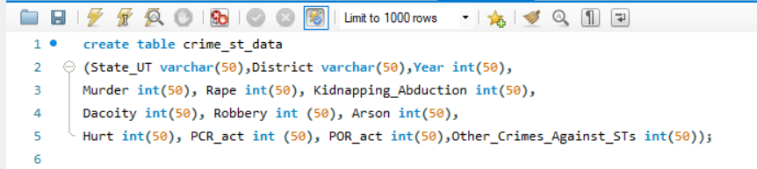

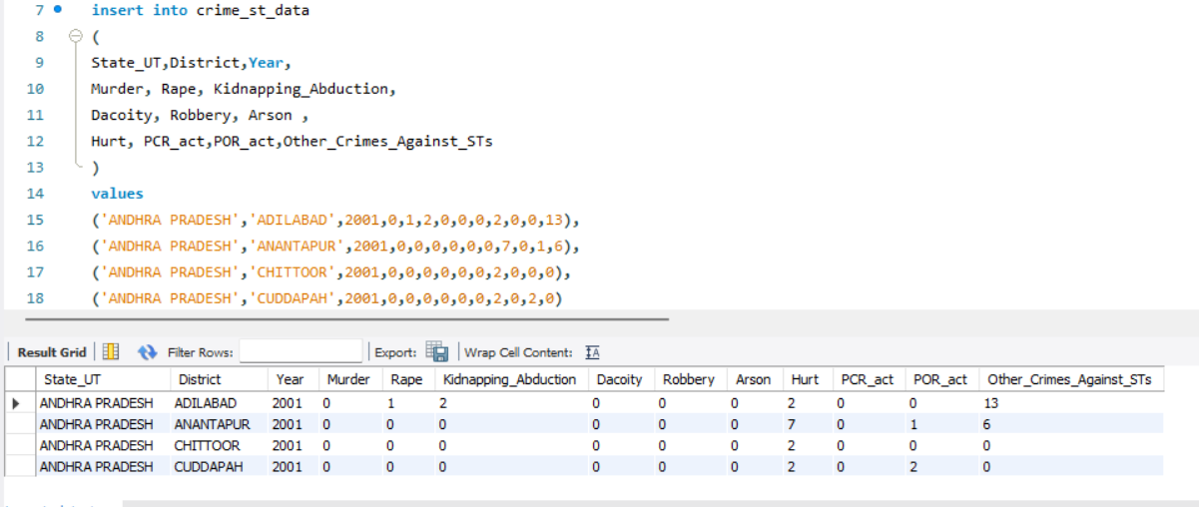

------------------------------------------------------------------------------------------------------------------------------------------

Question: - 3.5 Write SQL query to find the highest number of dacoity/robbery in which district.

Answer:- 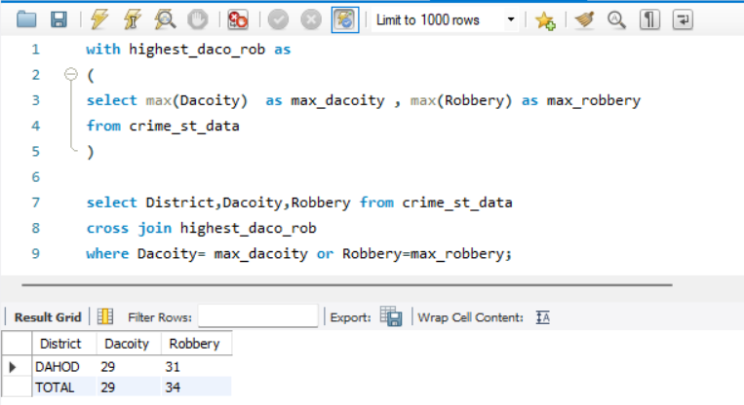

Question :- 3.6 Write SQL query to find in which districts(All) the lowest number of murders happened.

Answer:-

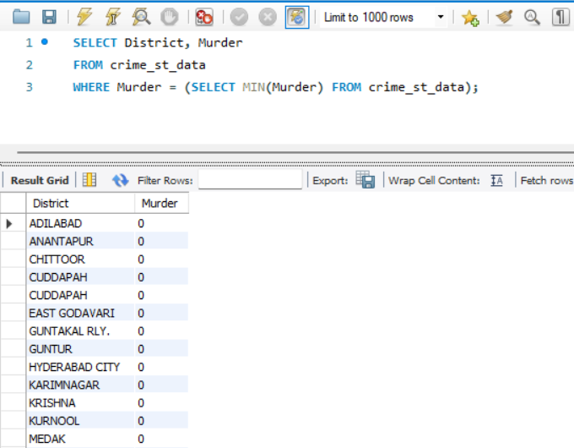

Question:- 3.7 Write SQL query to find the number of murders in ascending order in district and year wise.

Answer:-

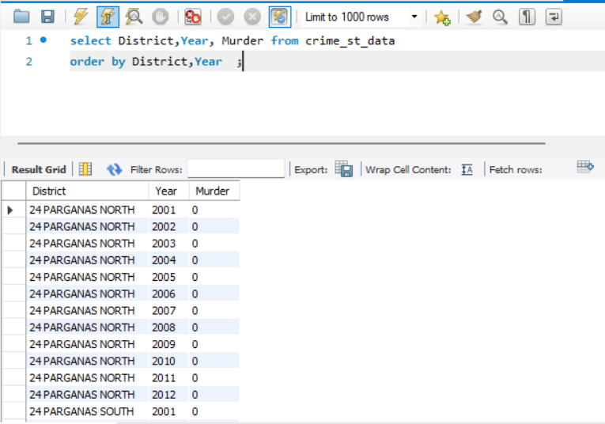

--------------------------------------------------------------------------------------------------------------------------------------

Question:- 3.8.1 Insert records of STATE/UT, DISTRICT, YEAR, MURDER, ATTEMPT TO MURDER, and RAPE columns only from 01_District_wise_crimes_committed_IPC_2001_2012.csv into a new table.

Answer:-

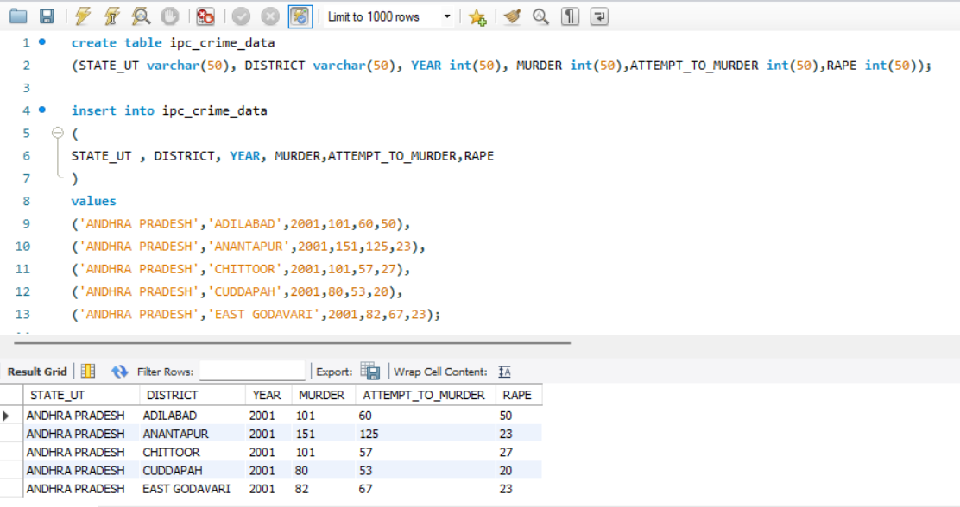

--------------------------------------------------------------------------------

Question:- 3.8.2 Write SQL query to find which District in each state/UT has the highest number of murders year wise. Your output should show STATE/UT, YEAR, DISTRICT, and MURDERS.

Answer:- 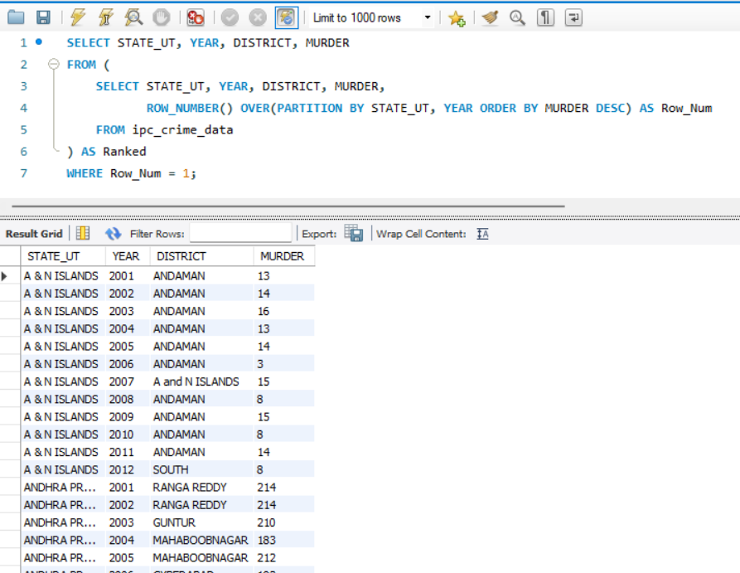

--------------------------------------------------------------------------------

Question no 3.8.3 and 3.8.4 present in another file(Jupyter)